# 

**The Haunted Trials**

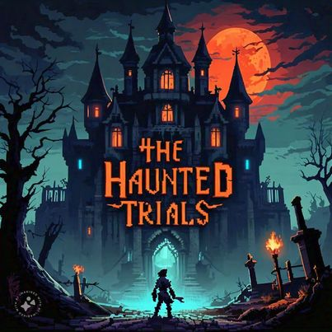

*“Face Your Fears, Solve the Secrets.”*

Developers:

Nathaly Kim Barinotto

Ryan Ciot

Waleed Muhammad

Jacob Almeida

October 8, 2024 - Present

**Title page 1**

**Executive summary 3**

**Overview 3**

**Related Games 6**

**Player Composites 8**

**Game World 8**

**Game Characters 9**

**Progression graph 10**

**Art direction 11**

**UI storyboards 12**

**Tags and dialogue 13**

**Technology Plan 14**

**Software architecture 16**

**Controls 17**

**Level design 17**

**Mechanics analysis 19**

**Schedule 19**

**Budget 21**

**Change logs 21**

# 

# Executive summary

The game is set in a Haunted House that is owned by Dracula and which has dozens of ghosts protecting him. What separates this game from traditional games is the haunted theme aspect of this game, and how puzzles and plot are incorporated into it. With a growing market for puzzle-murder mystery games and a rise in interest in dark/haunted themes, "The Haunted Trials" is poised to capture both gamers and critics, expanding its reach beyond traditional puzzle fans.

# Overview

**Genre:** Puzzle Adventure

**Target:** Teenagers/Young Adults

**Goal:** Solve each puzzle to get through all the levels and reach the final boss to kill him.

**Game Project Summary:**

Players will be spawned into a haunted house where they will have to solve puzzles in order to progress through the game. Throughout the game the player must avoid the ghosts because they have the power to kill the player which will lead to game over. In the first two levels, the player must either collect all the keys or just one key to be able to go into the next level. After the third level, the player will be brought to a room with a gun that they must retrieve. An arrow will pop up when they have gotten the item that will indicate to them the path to the final boss where their goal is to kill the final boss, who is Dracula. To kill the boss, the player must use the gun that they obtained to shoot power blasts at him and have his HP lowered to 0. But if the player’s HP is lowered to 0 (which can only happen when they come into contact with Dracula’s power blasts) the game will be over and they have lost the game. If they accomplish this, they have won the game.

**Core Concept**

"The Haunted Trials" spawns the player into a haunted house where they must solve intricate puzzles while evading deadly ghosts. The ultimate goal is to defeat Dracula, the owner of the manor, by solving said puzzles and using a gun that will be found in the game. The game blends horror and puzzles, creating an immersive experience that keeps players on the edge of their seats.

**Major Qualities**

### 1. Engaging Puzzle Mechanics

* Players will encounter a variety of puzzles that challenge their logic and creativity, from trying to capture all the keys while avoiding the ghosts to navigating complex mazes. Each solved puzzle unlocks bring the player to the next level/World and progresses the game.

### 2. Atmospheric Horror Experience

* The haunted house is designed with dark, moody visuals and eerie/ghostly sound effects. This will immerse the player in a world of suspense.

3. Dynamic Enemy Interactions

* Players must strategically avoid ghosts that go around the house. The fear of being killed adds urgency to the puzzle-solving aspect of this game.

### 4. Epic Final Showdown

* After solving each challenge, players face Dracula in an adrenaline-pumping battle. The unique mechanic of using the gun to shoot power blasts while dodging Dracula’s attacks provides a satisfying climax to the gameplay and keeps the player on his toes.

### 5. Progressive Difficulty

* The game escalates in difficulty as players advance, ensuring that both novice and experienced players remain engaged. Early levels introduce mechanics, while later levels require quick thinking.

The core mechanics of The Haunted Trials:

* One core mechanic is the collection of keys. In most of the levels there will be keys to collect (or just one). The player can collect them by just coming into contact with them. After they are collected, the player will be brought to the next level. One after the other, they will lead the player to the final boss which will possibly lead to the player winning the game.
* Another core mechanic is the ghosts. As the players navigate the game and try to solve the puzzle ghosts will be roaming around the haunted house, the goal of the ghost is to defeat the player which will lead to game over. Since the way to win the game is having the player solve each puzzle while not being caught by the ghosts. These ghosts provide an extra layer of challenge to the puzzles so that each one not only requires you to think to complete them, but you must do it fast in order to not get caught by the ghosts.
* A third core mechanic is the power blasts. To win the game, the player must defeat Dracula which can only be accomplished if his HP is lowered to 0. This can only happen if the player obtains a gun that is able to shoot power blasts that lower Dracula’s HP. Dracula can defeat the player by firing off his own power blasts. The only difference is Dracula’s are more powerful than the players. If Dracula hits the player enough times and their hp drops below 0 the game is over.
* The final core mechanic is one that may frustrate some people. There are no checkpoints in “The Haunted Trails.” This means the game must be completed on the players first try or else they must start from the very beginning.

Some games that are similar to this one:

* **Amnesia:** This survival horror game emphasizes exploration, puzzle-solving, and avoiding creatures in a dark and haunted setting.
* **Phasmophobia:** In this multiplayer game, players assume the roles of ghost hunters. They must gather evidence of paranormal activity while avoiding spirits.

# Related Games

This game was inspired by two very well-known games.

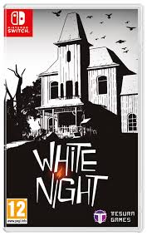

**The first one is White Night.**

In White Night, players navigate a mysterious, abandoned mansion where their goal is to piece together the mansion’s dark history. To accomplish this, the player must go through a series of puzzles. Solving these puzzles will solve them to unlock new rooms and progress the story. As players explore, they encounter ghosts that offer hints and deepen the narrative.

Ratings:

Metacritic: 67%

IGN: 5/10

Steam: [7/10](https://store.steampowered.com/app/301560/White_Night/)

Review: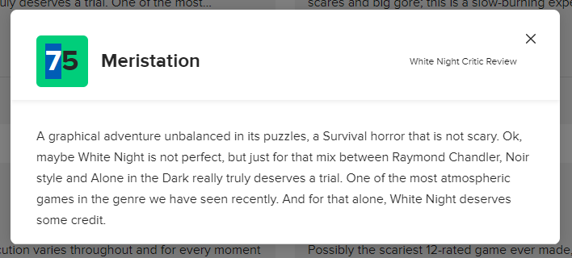

The core mechanics of White Night:

* The main core mechanic of this game is puzzle solving. To progress through the game, the player must solve puzzles which include interacting with objects in the environment to unlock doors, activate mechanisms, or reveal hidden passages.
* The second core mechanic is resource management. Light is a central mechanic, since players have to use matches to illuminate dark areas, revealing clues, paths, and hidden items. Managing the limited supply of matches adds tension and strategy to the game.
* The final core mechanic is narrative unfolding. The story is revealed through environmental storytelling, notes, and interactions with ghosts. Players piece together the mansion's history as they progress the game. To piece the game together, the player must solve the puzzles and challenges that they are faced with.

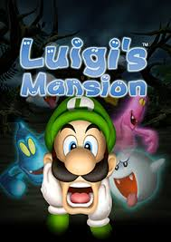

**The second game is Luigi’s Mansion**

Luigi’s Mansion is a video game where the goal is to save Mario and his friends who have been kidnapped by ghosts. The game takes place in a haunted mansion which Luigi wins in a contest. In order to rescue Mario, the player has to capture and defeat all the ghosts with the help of his Poltergust 3000. The game gets progressively more challenging with not only the ghosts themselves getting harder to defeat but the puzzles and challenges also get progressively more difficult.

Ratings:

Metacritic: 74%

IGN: 7/10

Steam: 8/10

Review:

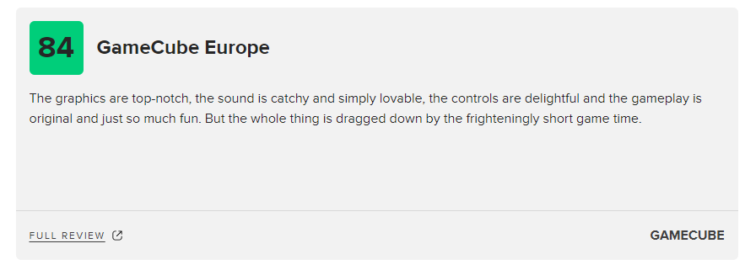

The core mechanics of Luigi’s mansion:

* The primary mechanic of this game is using the Poltergust 3000 to capture all the ghosts. Players must weaken ghosts with a flash of light before vacuuming them up which will lead to the death of the ghosts. After vacuuming all the ghosts and completing all the challenges, the player will be brought to the final boss where the player will have to use all their knowledge of the game to defeat him.
* Another core mechanic is the exploration aspect of this game. A big part of this game revolves around the players navigating through the haunted mansion, searching for keys to unlock rooms, solving puzzles to unlock rooms, and discovering secrets in all the different rooms. The game is riddled with replayability as every level has many hidden gems to collect in order to keep the player busy and make them come back to the game even after defeating the final boss.

# Player Composites

Target player #1:

Jake, a 17-year-old teenager and a high school student, walked back home wearily after a long exhaustive day of examinations and peer pressure. His friends had bailed on him for a party, and this left him feeling alienated and stressed. Entering into his dimly lit room, he had a look at his computer and game console. Immediately, a wave of relief came onto him. He remembered the word of "The Hunted Trials", a new game set in a haunted house full of puzzles and ghosts promising an escape into reality, a chance to face your fears, solve mysteries without judgments.

Target player #2:

Sophie, aged 21, was laying on her couch with her open untouched sketchbook in front of her. She had spent the week working on a big project, and today she just wanted to take a little break from reality. She was surfing her favorite gaming forum when she came across a thread entitled "The Hunted Trials," promising an exceptionally interesting art-entwined design, full of challenging puzzles. Her curiosity stirred, she thought, Why not?. Then, when booting up the game for the first time, she found herself mesmerized by both the visual and musical arts of the game. This haunted house was like a beautiful piece of artwork that came to life in her imagination with each ghost encounter.

# Game World

The point of view of the player will be that they went into a haunted house and one of their friends was murdered by the owner. Like previously mentioned, the goal of the game is to avenge the death of his friend who is Dracula. Because of the background story and who the killer is, the worlds in this game will all revolve around the haunted. Most backgrounds will have a halloween theme too. For example the first background image which is used for the tutorial levels:

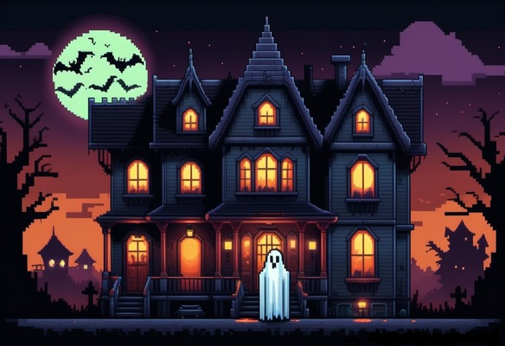

# Game Characters

**Player**

After the death of the player’s friend, Jacob, in a haunted house. The player has decided to stay and avenge his death. To do this, the player will have to kill the final boss, the killer who is Dracula (the owner of the home).The fact that the ghosts are trying to protect Dracula immediately makes them an enemy of the player. And since Dracula is the one who killed Jacob, he is also considered an enemy.

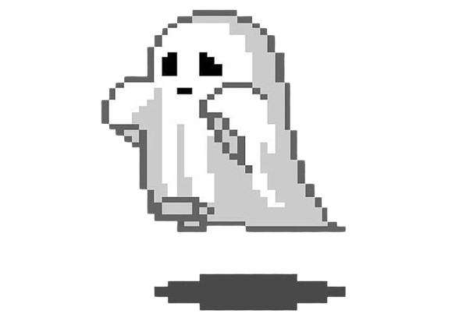

**Ghost**

The ghosts were assigned the task of protecting the owner of the home, Dracula (which makes them allies). They are shown in the game as white draped characters with a hole as eyes and a mouth. They will be moving randomly around the world and if in contact with the player, the player dies. Because of this, the main character is the enemy of the ghosts. 

**Dracula**

Dracula is the owner of the house and also Jacob’s murder. His goal is to stay alive during the last level, the final boss level. The only way his HP can go down is from the energy blasts the player will be able to shoot at him, although Dracula himself can also throw energy blasts. The fact that the player is trying to kill Dracula makes the player the enemy of dracula. Since the ghosts are protecting Dracula, they are allies.

# Progression graph

* **Tutorial levels:** the screen will have a text explaining the situation the player is in and any information the player may need to play the game. For example, the keys to move around the game, the keys in every level, the ghost’s ability to kill the player, etc…
* **Level 1:** The player must collect all the keys in the room while avoiding the ghosts to be able to go to the next level.
* **Level 2:** The player must go through a maze while avoiding all the ghosts. In this maze the player must go in the middle to get the key and then leave by the exit to go to the next level.
* **Level 3:** The key this time will be in a locked box. The player must open the box and retrieve the key by attaching all the wires that are the same colors together. Once the key is found, the player will be automatically sent into a “break” where they are in a hallway.
* **Break:** After the third level is accomplished, the player will be sent into a hallway where all they have to do is collect a gun by coming into contact with it. After that has been done, a message that says “Click the spacebar” and a yellow arrow pointing to the right will show up. The space bar will activate the gun which will be shooting energy blasts. This will be useful information for the final boss level. Then the player can take as long as a break that they need to relax and then when they choose to follow the arrow, they will be brought to the final boss level.
* **Final boss level:** With the gun found in the previous level, the player will have to use it to kill the final boss, Dracula. To do this the player needs to shoot the boss and lower his health point (HP) until it reaches 0. Once the HP reaches 0 the game will be won, but if the boss attacks the player with his own energy blasts then the players HP will go down and if it hits 0 then it will be game over

# Art direction

We will be going for more of a haunted/halloween for The Haunted Trials. Although since it is a small game, we would like to make the images and characters pixelated. Pixelated characters are a staple for many 2D based games including the very famous Super Mario Bros 1985. Each individual pixel on a character can make for an extremely unique and beautiful design. The goal of using 2D pixel models is to make something simple but beautiful that can be as memorable as the designs that came before it.

Examples of images that might be used:

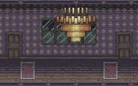

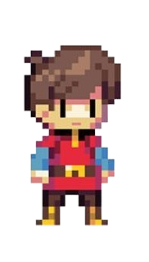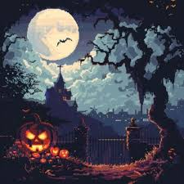



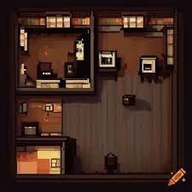



:

# UI storyboards





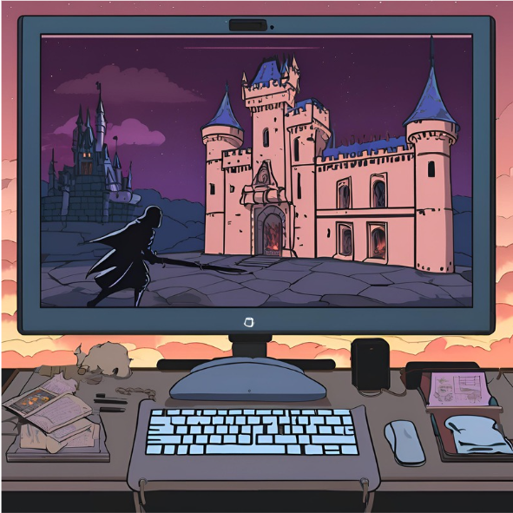

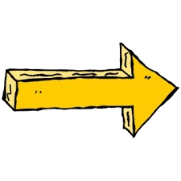



Good luck surviving this game!



# 

# Tags and dialogue

The Haunted Trials is a single player game. No communication is made to other active players. In order to point the player in the right direction there will be arrows that will be placed around the levels and ‘tutorial levels’ at the beginning of the game which will be more of a text that will be shown to the player to explain the situation and any core mechanics that they need to know in order to be able to play the game.

Tutorial levels dialogue texts:

1. “You and your friends decided to go to a haunted house, but after some time you realize your friend, Jacob, has gone missing. You found out that he was murdered by the owner of the house, Dracula. You decided to stay in the haunted house to avenge Jacob’s death, even after all your friends left, and kill Dracula."
2. “To be able to reach Dracula, you will have to go through each level and solve every puzzle in them. In each of the levels there will either be one or multiple keys to collect and once they've been collected you will be brought to the next level. You will be able to move by using the right, left, up and down arrow. The only way to die is by being touched by a ghost or by dying in the Final Boss level, which will lead to game over. Good luck!”

The break between the third level and the final boss level:

1. “Click the spacebar.”

Arrows used throughout the game: 



# 

# 

Sounds throughout the whole game:

1. When the player collects an item: “Retro coin 4” in pixabay.com
2. When it's game over: “Game over arcade” in pixabay.com

Sounds through the tutorial level to the Break:

1. “ghost atmosphere: ghostly singing”

Sounds in Level 3:

1. When the box is opening: “dorm door opening” in pixabay.com

Sounds in the Final Boss Level:

1. A more intense version of “ghost atmosphere: ghostly singing”
2. When the game has been won: “[piglevelwin2.mp3” in](https://pixabay.com/sound-effects/piglevelwin2mp3-14800/) pixabay.com

# Technology Plan

#### **1. Game Engine:** Greenfoot

* **Reason:** Greenfoot is a Java-based and Stride-based interactive development environment which allows people to design 2D games and simulations. It is recommended for game developer beginners, which is the main reason I think it is the perfect game engine for this game. The game will be produced using Stride

**2. Platform**

* **Target Platform**: PC
* **Reason:** Since this game will be done with the help of the indy industry and will be having a low budget, i think it is preferable to develop exclusively for PC.

#### **3. Development Tools**

* **Programming Language**: Java and Stride (We’ll be using Stride)
* **Version Control**:
  + GitHub will be used for managing source code and collaboration between all the developers.
* **Project Management Tools**:
  + Backlog for task organization, milestones, and progress tracking.
  + Instagram communication and feedback between all the developers.

#### **4. Art and Asset Creation**

* **2D Graphics Software**:
  + Google images for finding backgrounds, items, characters, etc. All tailored to the haunted theme.
  + Paint, an app, to create any needed images or edit them.
  + Remove.bg (website) to get rid of any background from the pictures chosen.
* **Sound**:
  + Websites, like pixabay and itch.io, will be used to find sounds for the game.

#### **5. Gameplay Mechanics**

* **Puzzle System**:
  + Custom Java and Stride classes to creative puzzles, logic-based challenges and item collections..
* **Ghost Mechanics**:
  + Implement behaviors for the ghost characters, like having them move around randomly and etc…

**6. Networking and Online Features**

* **Community Engagement**:
  + Utilize Greenfoot’s built-in sharing features to allow players to share their experiences and solutions to puzzles online.
* **Feedback Mechanism**:
  + Implement a simple feedback form within the game to gather player input for future updates.

#### **7. Testing and Quality Assurance**

* **Playtesting**:
  + All the developers and other people, like friends, will play the game to gather feedback on gameplay mechanics, difficulty, and other.

#### **8. Hardware Requirements**

* **Minimum Requirements**:
  + PC
  + RAM: 2 GB
* **Recommended Requirements**:
  + PC
  + RAM: 4 GB

#### **9. Post-Launch Support**

* **Update Strategy**:
  + The game will be playtested regularly to make the puzzles, ghost characters, and others better based on feedback received.
* **Community Involvement**:
  + Friends and family will be giving feedback and comments on the game.

# Software architecture

#### **1. Game Engine:** Greenfoot

* **Reason:** It provides a beginner-friendly environment for developing 2D games.

**2.** **Game Components**

* **Core Classes**:
  + **World Class**: The primary class that will be managing the main game state. The world classes will determine at which level the player is at.
  + **Actor Class**: Represents individual characters, items and anything else that will be added to the game.
* **Gameplay Components**:
  + **Puzzle Class**: A base class for all puzzle types, allowing for easy creation of different puzzles (e.g., item collection). Subclasses can implement specific behaviors and requirements.
  + **Ghost Class**: A class that controls the ghosts behaviors, with methods for movement, player’s elimination and others.

**3. User Interface (UI)**

* **Menu System**: In the tutorial levels, there will be direction symbols that will let the player go back and forth between the first couple worlds.
* **In-Game HUD**: A display for texts, HP status, and direction symbols. All while using the haunted theme.

#### **4. Audio System**

* **Sound :** Websites, like pixabay and itch.io, will be used to find sounds for the game.

# Controls

The game can only be played on a computer therefore only a handful of keys are necessary to play the game.

The keys and more:

1. Top arrow: up
2. Bottom arrow: down
3. Right arrow: right
4. Left arrow: left
5. (WASD will also be used for those who prefer that)
6. Space bar: shoot the energy blasts
7. Mouse pad/mouse: to move the mouse and be able to click on any arrows on the screen

# 

# 

# 

# Level design

* **Tutorial levels:**

**-**-The background will be the front of the haunted house in the middle of the night.

-The sound in the background will be of “ghost atmosphere: ghostly singing”

-There will be a text that will show up in a typing form.

-There will be a yellow arrow pointing to the right. If its clicked, the player will be sent to the next world where it'll have the same background and sound but different text

-On the second world, there will be a yellow arrow pointing to the left. If its clicked then the player will be sent to the first world with the first text. This will allow the player to go back and forth if they are not clear about something.

* **Level 1:**

-The background will be an open space inside a haunted house. There will be ghosts splattered around the room.

-The sound in the background will be of “ghost atmosphere: ghostly singing” .

-There will be ghosts splattered around the room, who will be moving in random directions.

-There will also be multiple keys around the room that the player must collect. Once the initial keys are collected, another round of keys will show up and the players must also collect those too. This is repeated again until, after the 3rd round, the player will be brought to the second level.

* **Level 2:**

-The background will be maze with the haunted house/halloween theme. The maze will have an open space in the middle and an exit.

-The sound in the background will be of “ghost atmosphere: ghostly singing”.

-There will be ghosts splattered around the room, who will be moving in random directions.

-In the middle of the open space in the middle, there will be a key that the player must collect.

-Once the player reaches the exit, they will be brought to the next level. But only if the player has collected the key, if it didn't then the player won't be able to reach the next level.

* **Level 3:**

-The background will be an open space with a haunted atmosphere.

-The sound in the background will be of “ghost atmosphere: ghostly singing”.

-There will be different collared wires on each side. The player will have to collect the wires and attach them to the correct ones, which is the one with the same color).

-There will be a box that contains a key, the player must open this box and collect the key by connecting all the right wires. Once the key is collected, the player will be sent to the Break.

* **Intermission break:**

-The background will be an open space with a haunted atmosphere.

-The sound in the background will be of “ghost atmosphere: ghostly singing”.

-The only item in the room will be a gun that the player must collect. Once it's collected, a text saying “Click the spacebar.” and an arrow pointing to the right. If the player follows the arrow and reaches the extremity of the world then it will be brought to the final boss level.

* **Final boss level:**

-The background will be an open space with a haunted atmosphere. If possible, Dracula’s bedroom.

-The sound in the background will be something similar to “ghost atmosphere: ghostly singing” but a little more intense since it is the final level.

# Mechanics analysis

* **Shooting:** The shooting game mechanic can be found in the final boss level. In this level the player can fire projectiles at the final boss which will lower his HP. The projectiles, which are energy blasts in this game, can be triggered by pressing the spacebar.
* **Collectibles**: This can be found in all three of the puzzle levels. Since the player must find multiple keys and retrieve each of them to be able to advance in the game.
* **Puzzle Elements:** This game mechanic can be found in each level. Level 1 being a puzzle where the player must retrieve all the keys, level 2 being one where they have to go through a maze and level 3 being one where the player must connect all the wires with the same colors together.
* **Health Management:**  The player and the final boss have their own health bars, which decreases when hit by any projectiles/energy blasts. The layer must avoid taking damage while continuing to shoot the boss.
* **Difficulty Scaling:** As the boss’s health decreases in the final level, its attack patterns will change, becoming more aggressive and more frequent. Which will lead to more tension and stress for the player.

# Schedule

Game proposal document due October 17th

Tutorial levels:

**Level 1 (finish by October 21th):**

1. World 1:

-Pick an image as the background (must have a haunted theme)

-Paragraph that introduces the situation (this text must do a typing motion, left to right)

-Pick a sound for the background (must fit the haunted theme)

1. World 2:

-Use the same image as World 1

-Paragraph that introduces the mechanics that must be known by the player to be able to play the game properly (this text must do a typing motion, left to right)

-Use the same sound for the background as the World 1 sound

**Level 2 (finish by October 28th):**

1. Pick an image as the background (must have a haunted theme and must be a maze with an exit and a spot where a can be found in.)
2. Do a code so that the player can move with the arrow keys.
3. Do the code so ghosts move around randomly.
4. Do the code so that when ghosts and the player collide, the player is eliminated and brought to Game Over World
5. Do the code so that when player and the keys collide, more keys appear (this happens twice) and when the third time all the keys are collected, the player is brought to Level 3 World
6. Pick a sound for the background (must fit the haunted theme)

**Level 3 (finish by November 4th):**

1. Pick an image as the background (must have a haunted theme and must be a an open space)
2. Create a box that contains a gun.
3. Create the wires on the side and make a code that makes it so that when all the same-colored wires are connected, the box containing the gun opens.
4. Make a code where the player can pick up and drop the wires.
5. Make a code so that when the player comes in contact with the key, an arrow to the right will appear.
6. Make a code where when the player follows the arrow, at the end he gets sent to the final boss level.
7. Pick a sound for the background (must fit the haunted theme)

**Final boss level (finish by November 11th):**

1. Pick an image as the background (must have a haunted theme and must be a an open space)
2. Create a code that has a HP bar, and a number that represents what the amount of HP he has, appear on top of the final boss.
3. Create a code that has a HP bar, and a number that represents what the amount of HP he has, appear on top of the player.
4. Make a code where the player can shoot energy blasts by clicking the space bar.
5. Make a code where the energy blasts, that come from the player, decrease the final boss’s HP when they come in contact.
6. Make a code where the energy blasts, that come from the final boss, decrease the player’s HP when they come in contact.
7. Make a code where the less HP the final boss has the more frequent he throws the energy blast and the more “aggressive” he becomes.
8. Make a code where when the final boss’s HP is equal to 0, the player will be brought to the Game Won World.

**Debugs (finish by November 18th):**

1. Test the game and fix any problems that occur/fix any bugs found.
2. Run the game by all the developers (and more if possible) and apply any suggestions that are approved.
3. Add any last second additions as well as running another set of tests to make sure the game runs smooth as butter.

# Budget

| **Category** | **Total Cost (CAD$)** |
| --- | --- |
| Development Costs | 0.00$ |
| Software and Tools | 0.00$ |
| Marketing and Promotion | 0.00$ |
| Miscellaneous Costs | 0.00$ |
| **Total** | 0.00$ |

# Change logs

Game proposal document:

| Date | Description of the change | Developer |
| --- | --- | --- |
| October 9, 2024 | Tasks #1-2-5-6-10 | Nathaly |
| October 11, 2024 | Tasks #3-12-15-17-19 | Ryan |
| October 13, 2024 | Tasks #8-11-14-16-18 | Waleed |
| October 14, 2024 | Tasks #4-7-9-13 | Jacob |
| October 16, 2024 | Revision of the whole document and correcting spelling mistakes. | Nathaly |

“The Haunted Trials” game:

| Date | Description of the change | Developer |
| --- | --- | --- |
| October 16, 2024 | Created the Tutorial Worlds and the texts in it. | Nathaly |